**Assignement 2**

1. **Color range- color range is tool that allow you to select particular area according to the color and then you can change hue,saturation and brightness of that area of image.**



1. **Lab mode- lab mode is used to increase or decrease the lightness without hurting the color and have two more color component.**

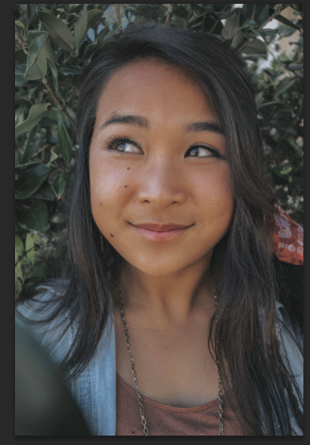

1. **Noise removal- it is the tool that is used to remove the noise of the image and increase the quality of the image.**

